Zavien Kellum

Dr Webb

Programming Digital Media

For this project, I presented to create an immersive audio-visual experience by incorporating a dynamic digital synth pad using a breadboard and Arduino kit, tone.is, and p5.js. The visual element will consist of a simple square shape, within which a movable object will be placed. The object's movement will be controlled by a joystick connected to a breadboard and Arduino, generating unique synth sounds based on its precise x and y axis coordinates.

To elevate the creativity of this project you can add ways to have the ability to customize the audio output by adding effects and adjusting various inputs, resulting in an array of distinct sounds. The visual aspect will also be captivating as the square will display different colors corresponding to the object's position on the x and y axis. The combination of user input from the joystick and the resulting changes in color and sound will create a fun and interactive experience, brimming with intriguing audio-visual interactions.

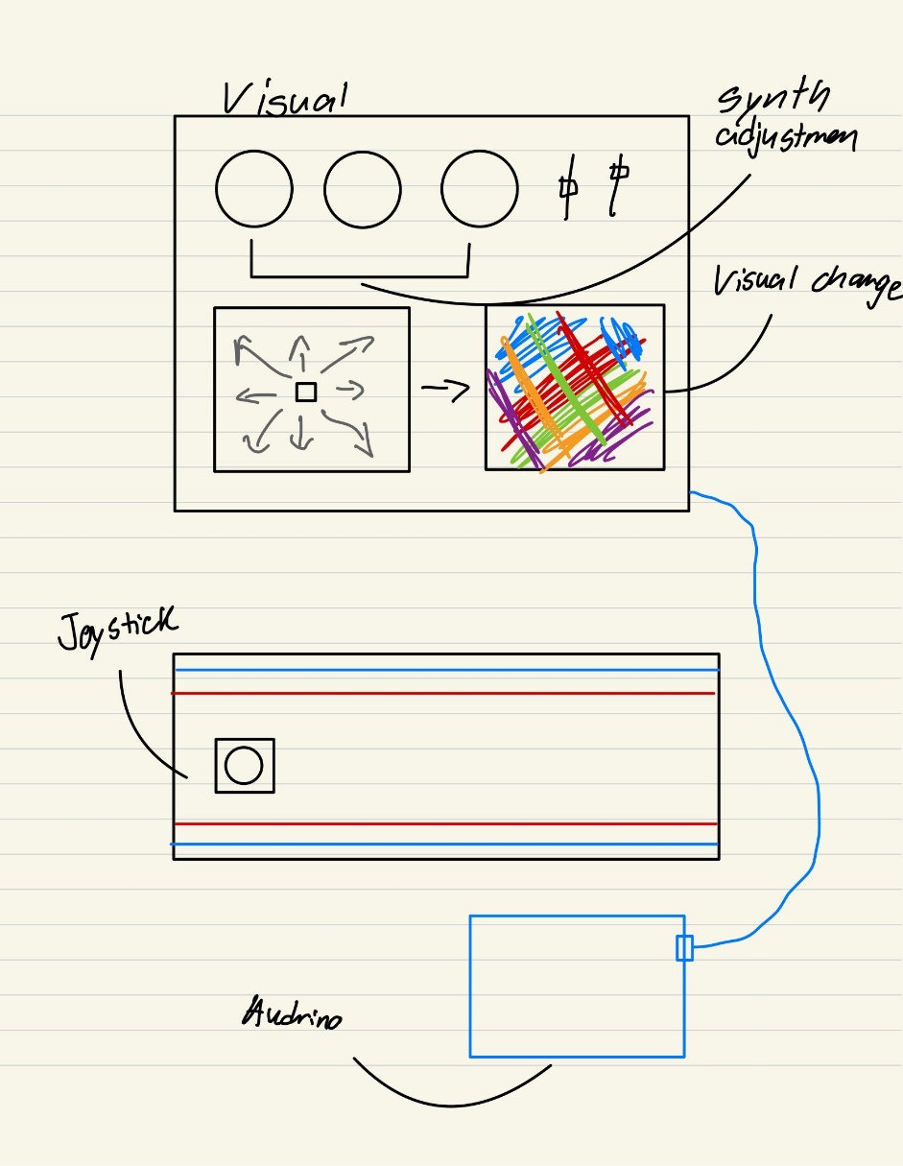

Figure 1

After completing this project, Figure 2 demonstrates significant improvements. Firstly, I have streamlined the process by eliminating separate controls for adjusting the synth distortion. Instead, I integrated these adjustments directly into the pad itself. Additionally, I implemented a feature where the color changes randomly, adding a dynamic element.

Now, with the joystick, you can easily manipulate the pitch and LFO (Low-Frequency Oscillator). The X-axis controls the speed of the LFO, while the Y-axis allows you to adjust the pitch.

Moreover, I have introduced the ability to display an image of a "mathematical rose" and modify its speed using a slider.

Looking ahead, I plan to further enhance the breadboard's functionality to provide an even more immersive user experience. This could include incorporating features like adjusting the sine wave oscillator and even introducing color customization options.

Figure 2